

Role Title
Examinations Services Manager Ref: ESM HU 05-19

Role Information
Role Type | Pay Band |  | Location |  | Duration | Reports to:
Full time | G 100% |  | Budapest, Hungary |  | Fixed term (for 1 year), renewable | Director Central European Cluster

Role purpose
To contribute to meeting British Council’s regional and country objectives through the efficient, effective and compliant delivery of UK examinations across Hungary and meeting income and volume targets. This will be achieved by:
- managing a strong and flexible operations team across the country to provide excellent levels of service to exams clients, candidates and stakeholders;
- adopting user friendly systems & processes to meet customer and client needs;
- ensuring high quality service standards are met;
- implementing business development activities which will contribute to exams business growth;
- contributing to the development of business opportunities in Hungary through cross-selling of products and services at a country level.

About us
The British Council is the UK’s international organisation for cultural relations and educational opportunities. We create friendly knowledge and understanding between the people of the UK and other countries. We do this by making a positive contribution to the UK and the countries we work with – changing lives by creating opportunities, building connections and engendering trust.

We work with over 100 countries across the world in the fields of arts and culture, English language, education and civil society. Each year we reach over 20 million people face-to-face and more than 500 million people online, via broadcasts and publications. Founded in 1934, we are a UK charity governed by Royal Charter and a UK public body.

Geopolitical/SBU/Function overview:
British Council Hungary is a small country operation within the EU Region. Hungary works within the Central European Cluster (CEC - Hungary, Slovakia, Czech Republic) under the leadership of Director Czech Republic. The in-country focus is on the teaching and exams businesses but there is also some successful English and Arts project work. As with many operations across EU, Hungary receives zero grant thus there is a need for self-funding sustainability for the operation as a whole. This implies a strong reliance on cross selling of products to develop viable business opportunities in all business streams.

The main role of Examinations Services is the marketing and administration of internationally-recognised UK examinations. The Hungary Exams business successfully delivers IELTS as the core product, but also delivers a substantial volume of Cambridge English qualifications, a range of professional exams, as well as the British Council owned test, Aptis.

Main opportunities/challenges for this role:
The Examinations Services Manager (ESM) leads the Exams Services team in Hungary consisting of 5 full time staff based in the Budapest office. In addition, the ESM manages the Exams Services network of third party centres in Hungary working closely with four centre network administrators.

The post will report to the North Cluster Exams Director and be part of the wider Hungary British Council team with approximately 16 contract staff, around 20 freelance teachers and additional invigilators / examiners.

Organogram
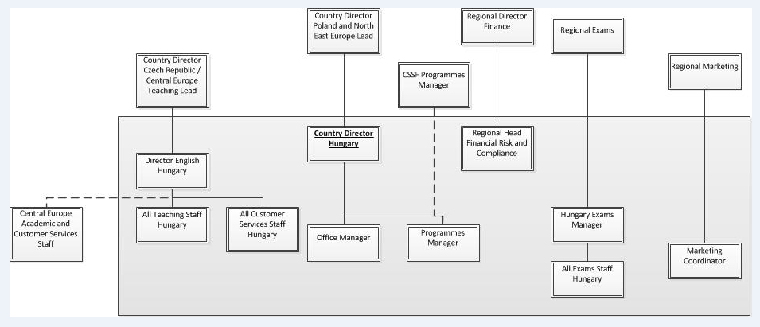

Main Accountabilities:
Strategy and planning
- Develop an overall business and operational strategy for Exams in Hungary in line with EU and cluster action plans and strategy.
- Prepare and own annual Exams marketing and financial plans for Hungary ensuring income, expenditure & surplus targets are met.
- Conduct all financial planning, analysis and reporting to corporate standards and deadlines.
- Support wider aims of the British Council through participation in management teams, in Hungary, CEC and North Cluster.

Compliance & exams delivery
- Ensure all areas of compliance are met – QCA*, EDI**, Child Protection, UK awarding body regulations, IELTS standards, data protection, Code of Conduct, mandatory training requirements for venue staff, financial requirements.
- Ensure successful implementation of new processes in liaison with country, CEC, regional and global exams teams e.g. BOSS (venue management), on line payment and registration, Computer Based Testing (CBT).
- Ensure that exams delivery meets demand by aligning and integrating processes, systems, people, venues, materials and equipment, etc.
- Lead on monitoring, evaluating and improving processes and systems, liaising with CEC, regional and global teams, to ensure high levels of performance.
- Manage exam processes to ensure dissemination of best practice across the centre network & full customer satisfaction.
* Quality & Compliance Assurance
**Equality, Diversity & Inclusion

Marketing and business development
- Raise profile of UK exams through events and other promotional tools.
- Manage key stakeholder relationships and develop new ones to strengthen the business.
- Ensure high quality Customer Service through appropriate CS resourcing for Exams customers.
- Promote integration with the English SBU*** to ensure development of business opportunities in Hungary and increase joint impact.
- Manage a cost & time efficient support system for the centre network to enable centre staff to maintain standards of exam delivery and customer service at the highest level.
- Conduct profitability studies as well as provide analysis & evaluation of impact of new developments (system/process) on achievement of targets.
- Conduct market research (including stakeholder analysis), analysing product trends & identifying and evaluating new opportunities.
***Strategic Business Unit
Finance and budget management
- Monitor volume, income and surplus to ensure business is on target. Seek efficiency savings / value for money to improve KPIs.
- Ensure all income reconciliations are prepared by deadline and signed off as per local guidelines.
- As owner of all Exams Services budgets ensure that all expenditure is documented as per required standards.

Leadership and HR
- Lead and motivate Hungary Exams team through a high quality, results focused approach.
- Identify Exams Services staff training needs and ensure that key needs are met.
- Line manage the Exams Services team with all the duties this entails (e.g. performance management).
- Lead on the recruitment and induction of new exams staff.
Review role profiles and the division of duties on a regular basis to ensure the most effective staffing model for the Hungary Exams business.

Key Relationships:
Internal:
- Director Hungary, Director CEC
- North Cluster Exams Director, Regional Exams Director
- Hungary Exams Services team, Czech & Slovak Exams Services teams
- English SBU colleagues in CEC
- Regional Exams Operations Manager
- Regional Commercial Development Manager
- Regional Cambridge English Business Development Manager
- Regional finance colleagues
- Exams Services Managers across EU
- Centre Network staff, Venue staff – supervisors, trainers and examiners

External:
- UK awarding body local / regional representatives
- Decision makers at educational and other institutions (existing & potential partners), official bodies
- Decision makers at supplier institutions for examinations (preparation centres – educational & corporate)

Role Requirements:
Threshold requirements: |  |  |  |  |  |  | Assessment stage
Passport requirements/ Right to work in country |  | A pre-existing right to live and work in Hungary |  |  |  |  | Shortlisting
Direct contact or managing staff working with children? |  | YES |  |  |  |  | N/A
Notes |  | Relevant criminal record check required.  Flexible working scheme (core hours 10am – 4pm). Staff may be required to work overtime at peak periods. Evening and weekend work as required, and some travel within EU.
Person Specification: |  |  |  |  |  |  | Assessment stage
Language requirements
Essential |  |  |  | Desirable |  |  | Assessment Stage
Ability to operate in English and Hungarian (both written and spoken) at a business level (equivalent to CEF level C1 or IELTS 6.5 or higher). |  |  |  |  |  |  | Shortlisting and Interview
Qualifications
Essential |  |  |  | Desirable |  |  | Assessment Stage
First degree or level equivalent |  |  |  |  |  |  | Shortlisting
Role Specific Knowledge & Experience
Essential |  |  |  | Desirable |  |  | Assessment Stage
Previous experience of Examinations delivery and operations. |  |  |  | Knowledge of the Hungarian educational market (in the context of examinations). |  |  | Shortlisting  Shortlisting
Role Specific Skills
Essential |  |  |  | Desirable |  |  | Assessment Stage
Experience of management of process-based and customer-focused or logistics business area. |  |  |  |  |  |  | Shortlisting and Interview
British Council Core Skills |  |  |  |  |  |  | Assessment Stage
Business Development (Level 3): Develops viable business. Defines and develops products / programmes / services which deliver British Council goals on impact, income and surplus within a defined area of business that responds to market opportunities and aligns to wider corporate strategies.  Managing Partnerships (Level 2): Works with stakeholders and partners. Communicates regularly with diverse stakeholders, customers and/or partners to build mutual understanding and trust.  Managing Finance and Resources (Level 3): Supports budget management. Monitors and controls an agreed budget within a defined area, producing reports and analyses and contributing to planning.  Using Technology (Level 1): Operates as a basic user of information systems, digital and office technology. Able to use office software and British Council systems to do the job and manage documents or processes.  Managing People (Level 3): Manages a team. Provides full line management to a team where all members are working in a similar area of expertise or business. Scope includes planning, setting objectives, role modeling an inclusive culture, recruitment, development and performance management. |  |  |  |  |  |  | Shortlisting and Interview  Shortlisting and Interview  Shortlisting and Interview  Shortlisting and Interview  Shortlisting and Interview
British Council Behaviours |  |  |  |  |  |  | Assessment Stage
Creating Shared Purpose (Essential level): Communicating an engaging picture of how we can work together.  Connecting with Others (Essential level): Making regular opportunities to understand others better.  Working Together (More demanding level): Ensuring that others benefit as well as me.  Being Accountable (Essential level): Delivering my best work in order to meet my commitments.  Making it Happen (More demanding level): Challenging myself and others to deliver and measure better results.  Shaping the Future (More demanding level): Exploring ways in which we can add more value. |  |  |  |  |  |  | Not assessed during recruitment.  Not assessed during recruitment.  Interview  Not assessed during recruitment.  Interview  Interview
Prepared by: |  |  |  |  |  |  | Date:
Philip Rylah, Director Examinations, EU |  |  |  |  |  |  | 14/05/2019

´The British Council believes that all children have potential and that every child matters – everywhere in the world. The British Council affirms the position that all children have the right to be protected from all forms of abuse as set out in article 19, UNCRC 1989´

